ECON 2B03 Summary

Author: Kemal Ahmed

Instructor: Dr. Cameron Churchill

Date: Winter 2014

*Math objects made using* [*MathType*](http://www.dessci.com/en/products/mathtype/)*; graphs made using* [*Winplot*](http://math.exeter.edu/rparris/winplot.html)*.*

Please join GitHub and contribute to this document. There is a guide on how to do this on my GitHub.

Table of Contents

Chapter 1 − Sustainability 2

Triple-Bottom Line 2

Seven Revolutions 2

Chapter 2 3

Methods of Interest Calculation 3

Lump Sum 4

Simple Interest 4

Compound Interest 4

Continuous Compound 5

Cash Flow Diagrams 5

Chapter 3 5

Equivalence 5

Compound Interest Factors 6

Compound Amount Factor 6

Present Worth Factor 6

Sinking Fund Factor 6

Uniform Series Factor 6

Capital Recovery Factor 6

Series Present Worth Factor 6

Arithmetic Gradient Series Factor 7

Growth-Adjusted 7

Chapter 4 7

Coupon Rate 7

Bond 7

# Chapter 1 − Sustainability

**model**: an simplification of reality that captures information useful and appropriate for a specific purpose

**linear product lifecycle**: energy in and out at every stage

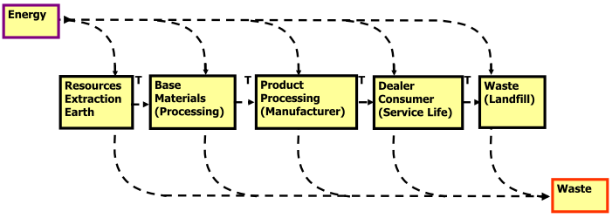

**closed-loop product lifecycle**: recycling, re-use, energy only lost at consumer level

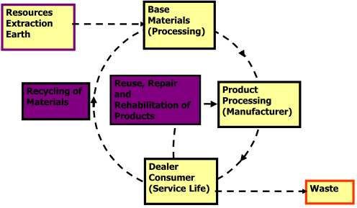

**Ingenuity Gap**: the gap between requirements and solutions, which is caused by an increasing complexity (?)

## Triple-Bottom Line

Focuses on:

* **Social sustainability**: productive service to society
* **Environmental sustainability**: resources/land
* **Economic sustainability**: cost efficient

## Seven Revolutions

1. Markets: compliance to competition
2. Values: hard to soft
3. Transparency: closed to open
4. Life-cycle Technology: product to function
   1. Companies responsible for entire product life-cycle
5. Partnership: subversion to symbiosis
   1. Companies cooperate
6. Time: wider to longer

# Chapter 2

**Cash-flow period**: time over which you are calculating effective interest rate

**Interest** [*I*]: compensation for giving up the money

**Annual interest rate** [*r*]: nominal interest rate over one year

**Present worth** [*P*]:

* The amount of money that is currently being dealt with (whether being loaned, or an annuity)
* Before initiating a time period exchange, the present worth is known as the **principle amount**
* Trying to bring all arrows on cash flow diagram to 0 (one period before the first payment)

**Future Worth** [F]: the future value of the time period exchange

**Interest period** [*m*]: interest compounds per year (not cashflow periods)

**Cash flow period (cfp)**:or *payment period* is how long it is between your payments

Don’t forget that there are 4 quarters in a year and 3 months in a quarter-year.

**Interest rate per cfp** [*i*]: interest for each interest period 

**Number of compounds per cfp** [*k*]: should never be a fraction

My way of calculating it is:

**Effective Interest rate** [ie]: overall interest rate that takes compounding and payment periods into consideration



**Effective interest per cash flow** [ie/k]: 

Your effective interest rate should be close to nominal interest rate/cash-flow periods per year.

## Methods of Interest Calculation

* Lump Sum
* Simple Interest
* Compound interest

### Lump Sum

**Lump sum**: one payment at the end of the time period exchange covers all the funds borrowed, so there is only one interest calculation. The interest on a lump sum does not change over time, but simply the amount paid.





### Simple Interest

**Simple interest**: a method of calculating interest that is based off the time it takes to pay off the loan and the principle amount



### Compound Interest

**Compound interest**: a method of calculating interest that charges interest on the principle as well as unpaid interest each “compound”



With compound interest comes a **compound period**, which is the amount of time, until interest begins to be charged on unpaid charges on top of previous unpaid interest. Compounding periods are assumed to have equal length.

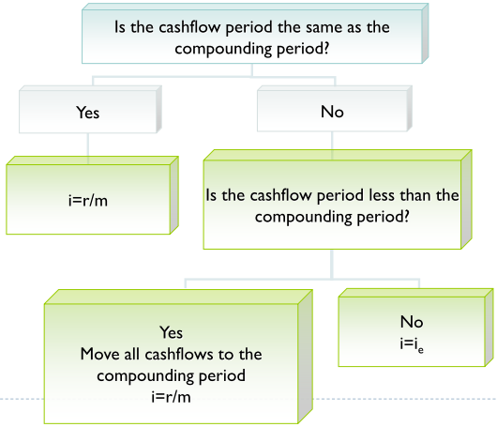

### Continuous Compound



## Cash Flow Diagrams

Cash flow diagrams are graphical representations of a system that aid in analysis of cash flows

Since each cash flow is paid as an impulse, instead of continuous outflow from an account, the cash flows are represented by arrows, which can be positive (up) or negative (down) on a chart where time is along the y-axis (represented horizontally) and the cash flow is represented along the x-axis (represented vertically)

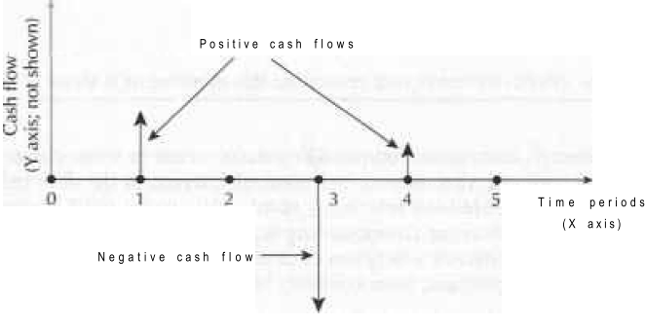

Sometimes when there are repeated points, with the same value, we represent the area with repeated points with a *squiggle* on the cash flow diagram:

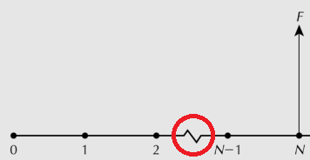

# Chapter 3

## Equivalence

**Equivalence**: when the value of something is the same at the one period as at a different period, which is determined by the interest rate

* **Mathematical**: comparing future to present by a factor of *time*
* **Decisional**: comparing future to present by a factor of *periods*
* **Market**: (?)

Note: a payment at time 0 can be assumed to occur at the end of the previous period

## Compound Interest Factors

A/B: A given B; A is unknown, B is known

**Number of payments** [*N*]: total periods − first payment + 1[interest begins from day one, payment does not]

### Compound Amount Factor





### Present Worth Factor



### Sinking Fund Factor



### Uniform Series Factor



### Capital Recovery Factor





**Salvage value** [*S*]: value after process is complete (usually 0)

### Series Present Worth Factor



### Arithmetic Gradient Series Factor



**Nominal increase of an annuity** [*G*]

## Growth-Adjusted

**Percentage Increase of an Annuity** [*g*]

**Base payment of Annuity** [*A*]

**Growth-adjusted interest rate** [i0]: 





**Discrete Model**: cash flows occur at the end of periods

**Continuous Model**: compound continuously over time

# Chapter 4

## Coupon Rate

**Coupon rate**: amount the investor received as interest payment

Fixed rate: fixed as a percentage of par value

Floating rate: adjustable interest payments

The coupon rate is stated for the year, but you need to cut that by how many times (multiply by face value/times received) you get the coupon, just as you need to cut down your nominal interest by number of compounds for any other interest

## Bond

**Bond**: default is 6 months

**Par/Face Value**: amount bond can be returned for at maturity

Comparison Methods:

* PW Method: examine present worth of all project cash flows
* AW method: convert all cash flows to annuities

Assumptions:

1. Costs & benefits are always measurable by money
2. Future cash flows are known with certainty
3. Cash flows are unaffected by inflation/deflation
4. Sufficient funds are available
5. Taxes are not applicable
6. Down payments ≤ proceeding cash flows

**Minimum Acceptable Rate of Return** (MARR): an interest rate that must be earned for a project for it to be worthwhile; would have to be larger for tech companies, since they can’t afford to stretch projects over longer periods of time

You want the thing with the least greatest present worth (PW)

If you need to compare to figure out which is the best option, doing an annual worth will save time because you only have to calculate for one year.